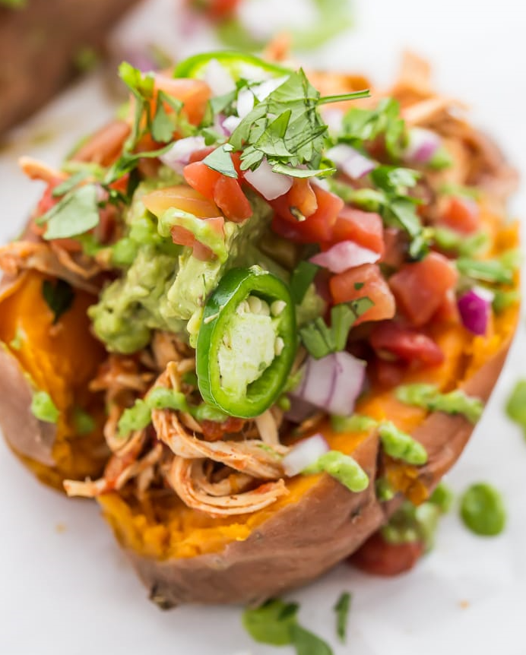**Mexican Stuffed Sweet Potatoes**

Servings [4](https://40aprons.com/whole30-instant-pot-mexican-stuffed-sweet-potatoes/)

**Ingredients**

Sweet potatoes

4 medium sweet potatoes, scrubbed

1 1/2 cups water

Chicken

2 chicken breasts

1 10-oz. can tomatoes with green chiles, undrained, any variety

1 tablespoon [taco seasoning](https://40aprons.com/taco-seasoning-recipe/%E2%80%8E)

Avocado-jalapeño sauce

1 avocado, peeled and seeded

1 jalapeño, stemmed

1/2 cup fresh cilantro leaves

1/2 cup water

2 cloves garlic

2 teaspoons [white vinegar](http://amzn.to/2v50tos)

1/2 teaspoon salt

Quick guacamole

2 avocados

1/4 cup avocado-jalapeño sauce

salt

Garnishes

jalapeños, sliced thin

fresh cilantro

salsa or more tomatoes with green chiles, drained

red onion, chopped

shredded cheese

sliced black olives

sour cream

**Instructions**

1. Bake Sweet Potatoes: Preheat oven to 400º F. Prick sweet potatoes all over with a fork then place directly on the oven rack in the middle position. Bake for 40-45 minutes or until easily pierced with a fork. Remove sweet potatoes from oven and set aside. If you have an Instant Pot, prick sweet potatoes all over with a fork. Place steaming trivet in the bottom of Instant Pot then pour 1 1/2 cups water in the pot. Place sweet potatoes on trivet then secure the lid and cook on Manual, high pressure for 16 minutes. Quick release pressure and remove sweet potatoes from trivet. Set aside.
2. Shredded Chicken: In the pot of a slow-cooker, combine all ingredients. Do not add water. Cook on low for 6 to 8 hours, or cook on high for 4 to 6 hours. After about 3/4 of the time, shred the chicken breasts with two forks and leave in the slow-cooker for the rest of the time. If you have an Instant Pot; combine chicken breasts, taco seasoning, and can of tomatoes with green chiles (undrained) in the pot of an Instant Pot. Do not add water. Secure lid and cook on Manual, high pressure for 20 minutes. Quick release pressure and remove chicken breasts from the pot. Shred with two forks then return to pot. Stir on Sauté mode a few minutes until sauce is absorbed.
3. Make your avocado-jalapeño sauce: combine all avocado-jalapeño sauce ingredients in the bowl of a food processor and process until smooth.
4. Guacamole: mash avocados and stir in ¼ cup avocado-jalapeño sauce and salt to taste.
5. Serve: with a knife, make a slit down the top of each sweet potato and press sweet potatoes ends toward the center to push open. Top with shredded chicken, guacamole, avocado-jalapeño sauce, and garnishes of your choosing. Serve immediately and enjoy!

Recipe adapted from 40aprons.com

Article submitted by Anna Fitzgerald, RDN, CD