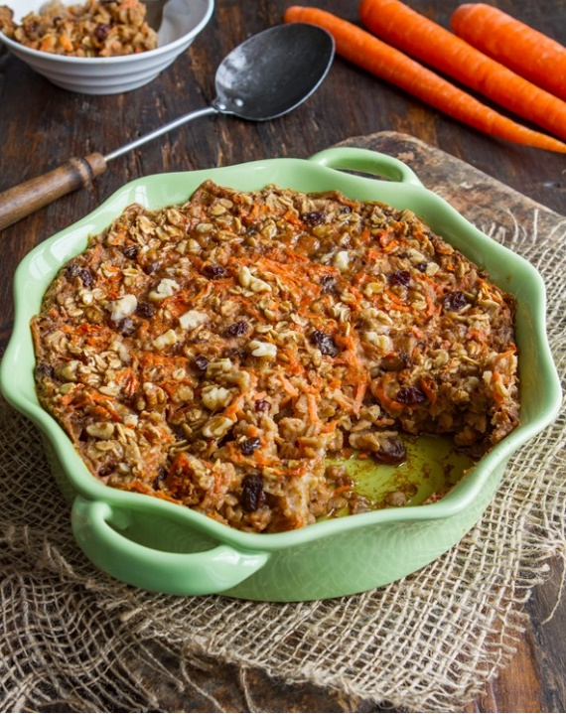**Carrot Cake Baked Oatmeal**

Recipe by Angela Liddon of Oh How She Glows

Yield: 6 large servings

Prep Time: 20 minutes

Cook Time: 30 minutes

**Ingredients:**

* 2 1/4 cups rolled oats
* 1 1/2 teaspoons baking powder
* 2 teaspoons ground cinnamon
* 1/4 teaspoon fine grain sea salt
* 1 1/2 cups lightly packed grated peeled carrots
* 2 1/2 cups unsweetened almond milk (or milk of choice)
* 1/3 cup pure maple syrup
* 2 teaspoons pure vanilla extract
* 1 1/2 teaspoons freshly grated ginger (or 1/2 tsp ground ginger
* 1/4 cup raisins or pitted chopped dates
* 1/2 cup chopped walnut halves

**Directions:**

1. Preheat oven to 375°F and lightly grease a 10-cup/2.5 qt. casserole dish. (8" x 11" rectangular casserole dish)
2. In a large bowl, mix together the rolled oats, baking powder, cinnamon, and salt.
3. In a medium bowl, whisk together the wet ingredients: shredded carrot, almond milk, maple syrup, vanilla, and fresh ginger.
4. Add the wet mixture to dry mixture and stir until combined.
5. Pour mixture into prepared casserole dish and smooth out with a spoon. Press down on the oatmeal with a spoon (or your hands) so the oats sink into the milk. Sprinkle on the walnuts and raisins (or dates, if using) and press down lightly again.
6. Bake, uncovered, for 32-37 minutes until lightly golden along the edges. The oatmeal will still look a bit soft or wet in some spots when it comes out of the oven, but it will firm up as it cools.
7. Let cool for about 5 to 10 minutes before serving. Garnish with a drizzle of maple syrup, or some yogurt. When the baked oatmeal is fully cool, it will firm up enough to be sliced into squares.
8. Leftovers should keep for 3 to 5 days in the fridge or 3 to 4 weeks in the freezer. Enjoy it warm or chilled straight from the fridge!

**Tips:**

This can be prepared the night before. Simply cover the casserole dish with foil and place it in the fridge overnight. In the morning, remove the foil and bake. It needs about 5 minutes less bake time when the mixture sits overnight in the fridge.